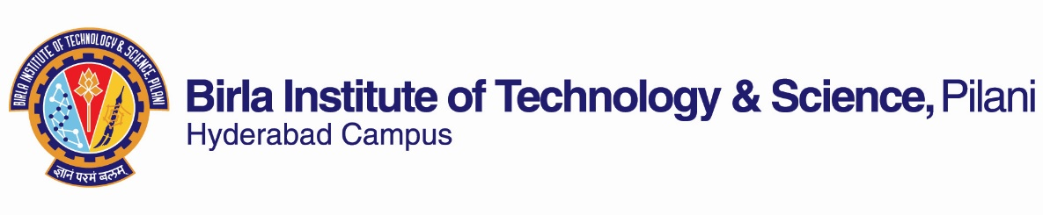

**FIRST SEMESTER 2022-2023**

**Course Handout (Part II)**

Date: 29-08-2022

In addition to part-I (General Handout for all courses appended to the time table) this portion gives further specific details regarding the course.

*Course No.* : CHEM F415

*Course Title* : Frontiers in Organic Synthesis

## Instructor-in-Charge : **TANMAY CHATTERJEE**

**Scope and Objective of the Course:** This course is designed to give understanding of traditional organic  
reactions and synthesis up through modern synthetic reactions with concurrent development of strategies for  
synthesis design. An emphasis will be placed on assembling the most important reaction methodologies in  
the context of complex molecule synthesis.

**Textbooks:**

1. Paul Wyatt & Stuart Warren, Organic Synthesis: Strategy and Control, Wiley (2008).

**Reference books:**

1. **R1.** J. Clayden, N. Greeves, S. Warren, P. Wothers, Organic Chemistry, Oxford Univ. Press (Second South Asia Edition, 2012).
2. **R2.** W. Carruthers, I. Coldham, Modern Methods of Organic Synthesis, Cambridge Univ. Press, 4th ed. (2004).
3. **R3.** B. D. Gupta and A. J. Elias, Basic Organometallic Chemistry: Concepts, Syntheses and Applications, Universities Press, 1st ed., 2010.

**Course Plan:**

|  |  |  |  |
| --- | --- | --- | --- |
| **Lecture No.** | **Learning objectives** | **Topics to be covered** | **Chapter in the Text Book** |
| 1-9 | To learn selectivity concept in design and synthesis of complex and optically active  molecules | Background of Chemo-, Regio- and Stereo-Selectivity with relevant examples | TB: Ch 2,3,4 |
| 10-17 | To have mechanistic knowledge of carbon-carbon bond forming reactions in organic synthesis | Introduction and selective examples on  metal-catalyzed sp, sp2 and sp3 C-C  formation and C-X (X = heteroatom)  couplings. | TB: Ch 18,  **R1:** Ch 40, **R2**: Ch 1.2.4, **R3**: Ch 16 Class notes |
| 18-22 | To understand the roles of transition metals in constructing carbon-carbon and carbon-heteroatom bonds | Metal-catalyzed carbocyclization: From Ru and Rh-mediated cycloadditions to Pt and Auchemistry; Ring closing metathesis.Baldwin rules for cyclization reactions | R1: Ch 40,  **R3**: Ch 15 Class notes |
| 23-26 | To learn the use of cross-coupling reactions in  multi-step synthesis | Direct functionalization of olefins, including hydroamination, hydrogenation, hydrosilylation, hydroformylation. | **R3**: Ch 12-13  Class notes |
| 27-32 | To gain knowledge on different methods to form radicals and their potential applications in C-C and C-X bond formation | Introduction, generation of radicals  using different methods and potential application for C-C and C-X bond formation. | R2: Ch 4.1, Class notes |
| 33-37 | To have knowledge on multi-bond forming processes and impact  on diversity-oriented synthesis; use of advanced concepts in  complex organic syntheses leading to bioactive and natural compounds | Introduction and emphasis on Ugi, Mannich, Biginelli reaction, Pauson–Khand reaction, Passerini reaction. Introduction and selective examples of Tandem reactions. | TB: Ch. 36, Class notes |
| 38-42 | To understand the importance of metal free catalysis and their usefulness in organic  synthesis | Need of metal free catalysis, introduction to the development of organocatalysis: amine catalysis (enamine and iminium ion); towards metal-free catalysis, phase transfer catalysis. | Class notes |

**Evaluation Scheme:**

|  |  |  |  |  |
| --- | --- | --- | --- | --- |
| **Component** | **Duration** | **Weightage (%)** | **Date & Time** | **Nature of Component** |
| Mid-Semester Examination | 90 min | 30 | 31/10 11.00 - 12.30PM - | Closed book |
| Class tests/Quizzes | - | 20 | Continuous/TBA | Closed book |
| Seminar | 10 min | 10 | Continuous/TBA | Open book |
| Comprehensive Examination | 180 min | 40 | 17/12, AN | Open book (15%) + Closed book (25%) |

**Learning Outcomes:** The learning outcomes of this course are the understanding of the concept of selectivity in organic synthesis and having the knowledge about the applications of the following topics in modern organic synthesis: (i) C-C cross-coupling reactions, (ii) metal-catalyzed or metal-mediated cyclization and cycloaddition reactions, (iii) hydroamination, (iv) hydrogenation, (v) hydroformylation, (vi) radical chemistry, (vii) multicomponent reactions, (viii) metal-free synthesis, and (ix) organocatalysis.

**Academic Honesty and Integrity Policy**: Academic honesty and integrity are to be maintained by all the students throughout the semester and no type of academic dishonesty is acceptable.

**Chamber Consultation Hour:** To be announced in the class.

**Notices:** All the notices will be uploaded in CMS and/or will be displayed in Chemistry Department Notice Board.

**Make-up Policy:** Make-up(s) will be granted only for genuine reasons according to BITS guidelines.

**INSTRUCTOR-IN-CHARGE**